# File permissions in Linux

## Project description

You are a security professional at a large organization. You mainly work with their research team. Part of your job is to ensure users on this team are authorized with the appropriate permissions. This helps keep the system secure.

Your task is to examine existing permissions on the file system. You’ll need to determine if the permissions match the authorization that should be given. If they do not match, you’ll need to modify the permissions to authorize the appropriate users and remove any unauthorized access.

## Check file and directory details

I used “ls -la” to check all file in the “/home/researcher2/projects” directory, both shown and hidden, and their permissions.

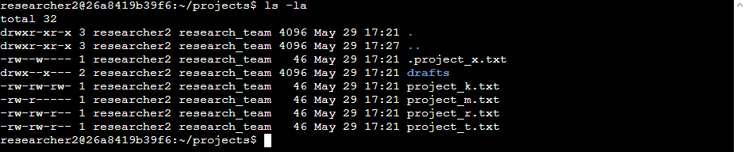

## Describe the permissions string

* Files:
  + project_k.txt
    - user = read, write
    - group =read, write
    - other = read, write
  + project_m.txt
    - user = read, write
    - group = read
    - other = none
  + project_r.txt
    - user = read, write
    - group = read, write
    - other = read
  + project_t.txt
    - user = read, write
    - group = read, write
    - other = read
  + .project_x.txt
    - user = read, write
    - group = write
    - other = none
* Subdirectories:
  + Drafts
    - User = read, write, execute
    - Group = execute
    - Other = none

## Change file permissions

The organization does not allow others to have write access to any files. So I take away the other write permission for “project_k.txt” using “chmod o-w project_k.txt” and to make sure permissions were changed I used “ls -la” to check.

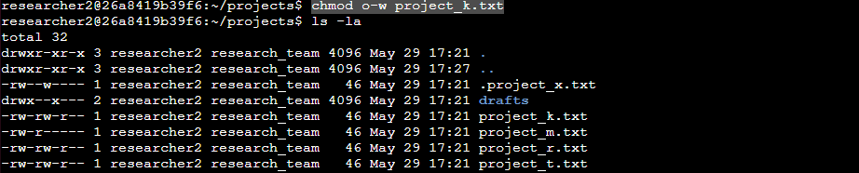

## Change file permissions on a hidden file

The research team has archived **.project_x.txt**, which is why it’s a hidden file. This file should not have write permissions for anyone, but the user and group should be able to read the file. So I used “chmod u=r,g=r .project_x.txt” to change user and group to read only and used “ls -la” to check.

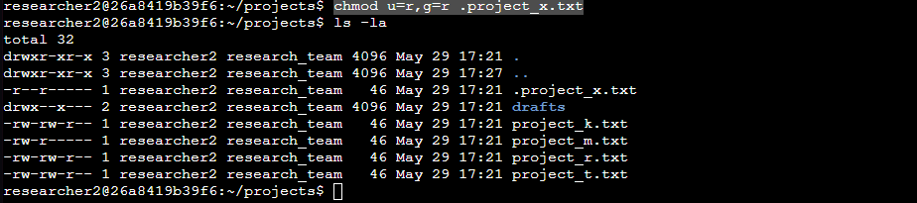

## Change directory permissions

The files and directories in the projects directory belong to the researcher2 user. Only researcher2 should be allowed to access the drafts directory and its contents. So I used “chmod g-x drafts/” to take away execute permissions from group and used “ls -la” to check.

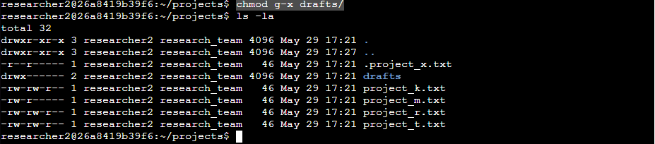

## Summary

After examining the files and subdirectory in “/home/researcher2/projects” using “ls -la”, I saw the current permission for each file and subdirectory, including hidden files. Using the information about what permission are and are not allowed is used various “chmod” commands to alter permissions in order to make sure users have the correct permissions while also making the security standard are where they need to be